AN EXPLORATIVE DATA ANALYSIS AND VISUALIZATION OF EFFECT OF FLOODING IN MALAWI

**Datacraft Team**

Contents

1.0 INTRODUCTION 2

1.1 Flooding in Malawi 3

1.1.1 Flood warning procedure in Malawi 4

1.2 Data Visualization 5

2.0 DATA AND METHODS 5

2.1 Gathering data 5

2.2 Food Prices 6

3.3 Food security Indicators 10

2.4 Healthsites 15

2.5 Precipitation data 15

LIMITATIONS 19

CONCLUSION 19

References 19

# 

# 1.0 INTRODUCTION

## 1.1 Flooding

According to the Microsoft Encarta dictionary, a flood is an overflow of water that submerges land that is usually dry. In the sense of "flowing water", the word may also be applied to the inflow of ocean tides. Often caused by heavy rainfall, rapid snowmelt or a storm surge from a tropical cyclone or tsunami in coastal areas, floods are the most frequent of all the natural disasters. Owing to their great significant concern in agriculture, civil engineering, and public health, floods are a very dedicated area of discipline in hydrology.

Between 80 - 90% of all documented disasters from natural hazards over the past 10 years had resulted from floods, droughts, tropical cyclones, heat waves and severe storms. Floods are also increasing in frequency and intensity, following the trend of extreme precipitation which is expected to continue rising due to climate change. From 1998 to 2017, floods had affected more than 2 billion people worldwide *(WHO, 2017).*

While drowning accounts for 75% of deaths in flood disasters *(WHO, 2017)*, the latter can have medium- and long-term health impacts, which includes:

* Water- and vector-borne diseases such as cholera, typhoid or malaria
* Injuries, such as lacerations or punctures from evacuations and disaster cleanup
* Chemical hazards
* Mental health effects associated with emergency situations
* Disrupted health systems, facilities and services, leaving communities without access to health care
* Damaged basic infrastructure, such as food and water supplies, safe shelter, etc.

## **1.2 Flooding in Malawi**

Malawi is highly vulnerable to the impacts of extreme weather events given its location along the great African Rift Valley, climate variability and change, environmental degradation, rapid population growth, and unsustainable urbanization. The most common weather-related shocks affecting the country include floods, drought, stormy rains and hailstorms. Over the past five decades, Malawi has experienced more than 19 major floods and seven droughts, with these events increasing in frequency, magnitude and scope. These disastrous events have had a significant impact on people’s lives, livelihoods and socioeconomic infrastructure in the affected areas, pushing a large number of people into poverty and food insecurity *(UNICEF, 2019)*.

With the events following the floods in 2015, the impact on the affected population has been cumulative. In the pre-disaster period, about 3.3 million people in the flood affected districts were already categorized as food insecure. In 2016/2017, the national poverty rate stood at 51.5%, with most of the poor (59.5%) living in rural areas. In Malawi, the level of inequality is high, with the Gini coefficient standing at 0.433 in 2017. Thus, disruptions to livelihoods resulting from natural disasters and other causes are likely to widen the gap between the poor and the well-off *(Malawi Government data, 2019)*.

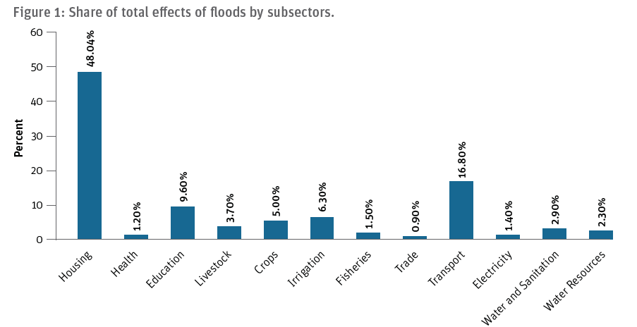

### 1.2.1 **Flood Warning Procedures in Malawi**

There are different models and services put in place by the Malawian Government and people to warn on incoming floods.

1. Department of Climate Change and Meteorological Services: The DCCMS is mandated to monitor, predict and provide information on weather, climate and climate change, that would contribute towards the socio-economic development of the country. Their climate forecast system is categorized as

* Short-range weather forecasts (24 hours – 3 days)
* Medium-range weather forecasts (7 days, 10 days, monthly or more)
* Long-range forecasts (decadal and seasonal weather outlook)

1. Department of Water Resources: Malawi’s DWR is mandated to achieve sustainable and integrated water resource management and development that make water readily available and equitably accessible to and used by all Malawians. DWR Flood Warnings Services includes:

* Provision of tailor-made forecast (as a decision support tool) for planning and preparedness by weather and climate sensitive sectors.
* Wide range of forecasts for aviation, marine, water resource, agriculture and insurance.
* Lightening advisory and flash flood guidance, dry spells and drought advisories, flood forecasting & warnings.

## **1.3 Data Visualization**

According to Wikipedia, Data visualization is the graphic representation of data. It involves producing images that communicate relationships among the represented data to viewers of the images. This communication is achieved through the use of a systematic mapping between graphic marks and data values in the creation of the visualization. This mapping establishes how data values will be represented visually, determining how and to what extent a property of a graphic mark, such as size or color, will change to reflect changes in the value of a datum. According to Vitaly Friedman (2008) the "main goal of data visualization is to communicate information clearly and effectively through graphical means. It doesn't mean that data visualization needs to look boring to be functional or extremely sophisticated to look beautiful. To convey ideas effectively, both aesthetic form and functionality need to go hand in hand, providing insights into a rather sparse and complex data set by communicating its key-aspects in a more intuitive way.

The common visualization techniques are divided into three categories: data visualization, information visualization, and interactivity (Khan & Khan, 2011). Data visualization is the study of the visual representation of data, which means information that has been abstracted in some schematic form, including attributes or variables for the units of information. In contrast, information visualization concentrates on the creation of approaches for presenting abstract information in intuitive ways (Thomas and Cook, 2005).

## 1.4 Objectives of This Report

The primary objective of this challenge is to interpret and generate insights from available data on the 2015 flooding and its aftermath specifically in southern Malawi, using original visualization and relevant stories.

* To explore the impact of the 2015 floods on the Southern Malawian society
* To generate a powerful report that effectively tells not just the story but unravels all the possible perspectives of the flooding event using quality visualizations.

# 2.0 Data and Methods

## 2.1 Data Understanding

## We were provided a variety of data comprising healthsites, demographic and health surveys, food prices, food security indicators, demographic, weather data, socio-economic indicators and spatial data (shapefiles, etc.), and performed preliminary analysis to understand what may be relevant to us. We narrowed our focus to data having moderate to high informativeness concerning southern Malawi,

## food prices dataset containing collated prices of major food items exported, imported, and cultivated in Malawi. This dataset also reported the prices by markets in the country’s regions.

## Weather dataset that covered the precipitation records for Malawi from 1991 to 2016.

## Healthsites data sheet containing 284 records of healthcare services rendering institutions.

## Food security indicators.

## All available demographic and health data consisting of the historical and current observations relating to vital indicators.

## Addition information was gathered from news sites, blogs, research papers, articles and public data given by the Malawian Government. Sources of these information are properly cited.

## 2.2 Data Preparation

## We carried out series of exploratory analysis and preprocessing on most of the data provided. Starting with the food prices; we calculated the median values for the individual food items and grouped the results by country region and food category. This approach was most suitable because the median prices were not affected by any outliers.

## For the rest of the datasets, we removed ambiguous variables that offered little or no information to the purpose of the generating insights. These variables include table keys, ids, DHS codes for indicators, etc. We also removed columns with duplicate values and rows with very sparse information, dropped data having very old survey years of collection, and generally data that weren’t informative enough for reporting on the flood disaster.

## 2.3 Methodology

## 

# 3.0 Food and Agriculture

Malawi is a small country with an estimated land area of 11.8 million hectares, of which Lake Malawi occupies one-fifth of the total. Out of 9.4 million hectares of land, approximately 5.3 million ha, or 56 percent, is cultivable. The Malawi economy is characterized by a high dependence on agriculture, a narrow industrial base and weak intersectoral linkages. The agricultural sector currently accounts for about 42 percent of GDP and 81 percent of export earnings (FAO). The country’s largely rural population depends heavily on crop production for its livelihood, most notably the production of maize, which accounts for three-fifths of daily calorie consumption (Ecker 2009). Agriculture and downstream agro-processing generate half of gross domestic product (GDP) and four-fifths of total export earnings and employment (Benin et al. 2008). Climate shocks therefore have a potentially profound direct effect on the agricultural sector and farm households while also indirectly affecting other economic sectors and nonfarm households through price and production linkages.

## 3.1 Food Prices

The prices analyzed in this report were recorded median price values across markets in the three regions of the country. With more emphasis on items that constitute majorly in Malawi’s trade and consumption, the food crops were generally grouped under;

1. Pulses and Nuts
2. Cereals and Tubers

***Figure 3.1.1* Sum of median prices in food category by region, described by the percentage in total**

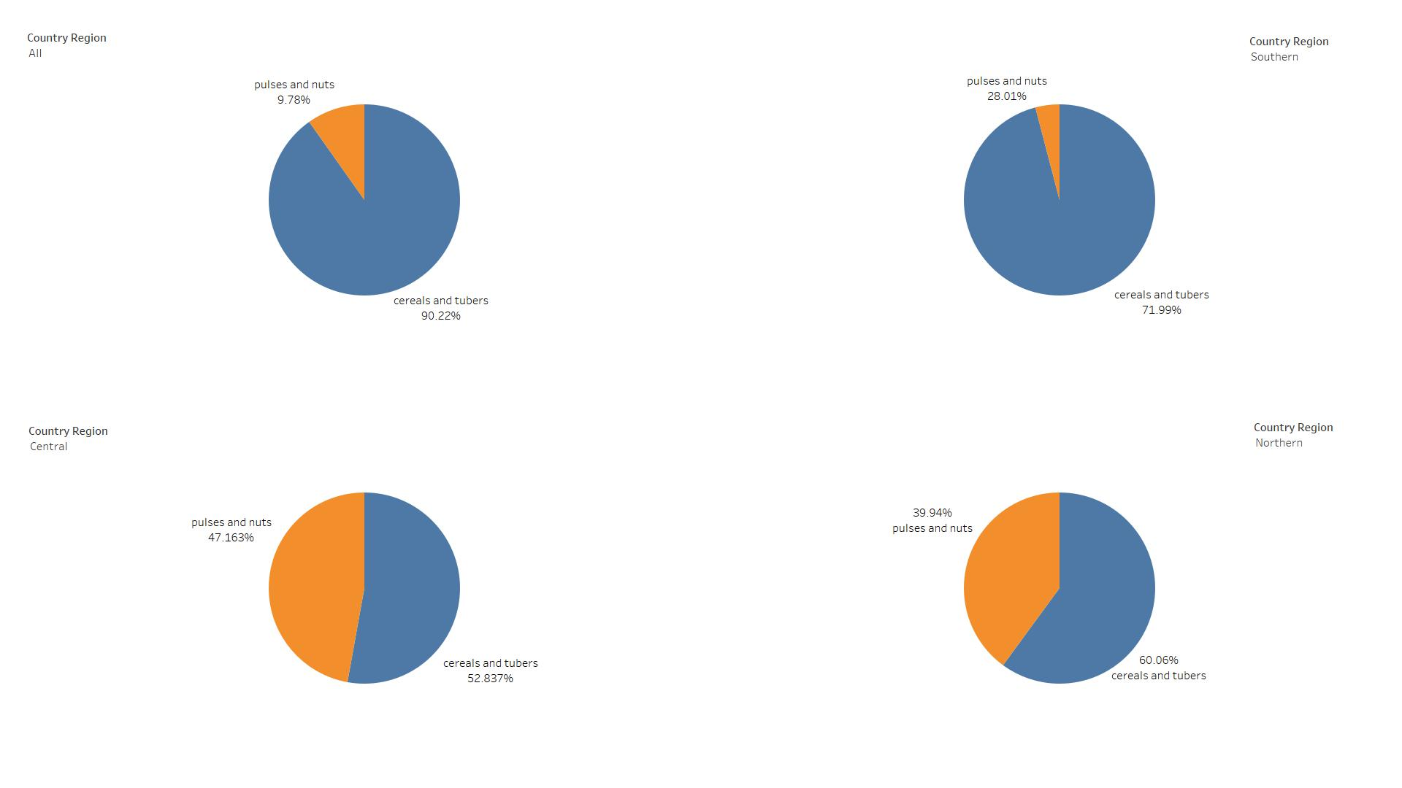

From the chart above, it was very evident that cereals and tubers constituted most of Malawi’s food crop production, exports and imports for the time frame considered. With the southern region contributing most of the overall 90.22% for cereals and tubers. The trend for this is shown below in figures 3.1.2 and 3.1.3

***Figure 3.1.2* Sum of food category trend over the years from 2014 to 2020**

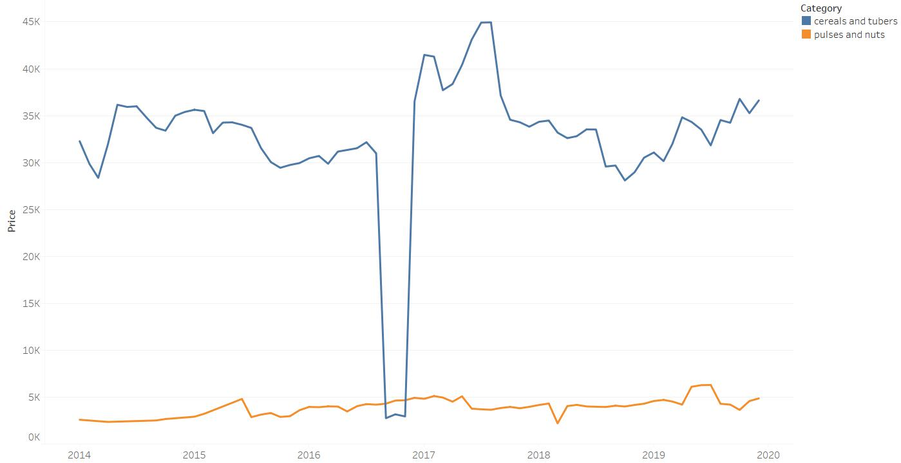

The sum of prices for pulses and nuts did not exceed MWK 7,500 while cereals and tubers reached an all-time high of MWK 45,000 in July – August 2017.

***Figure 3.1.3* Sum of food prices by country region over the years 2014 to 2020**

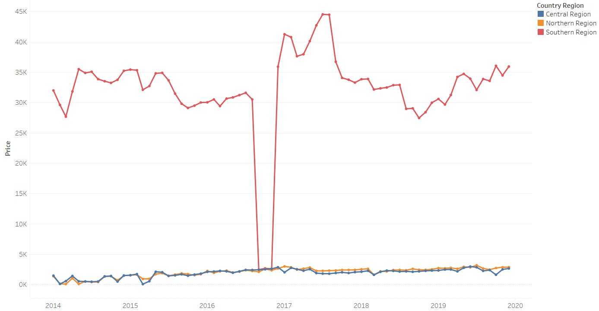

Looking at the chart by quarter of years it is immediately observed that there was no significant change in total prices for southern Malawi from the second quarter of 2014 to the second quarter of 2015, which covered the period of both the extreme rainfall and flooding of the southern region. There was however, a steep plunge from MWK 102,000 in the second quarter of the flood year to just below 90,000 in the fourth quarter of the same year.

***Fig. 3.1.4* Sum of food prices by country region in quarter of years 2014 to 2020**

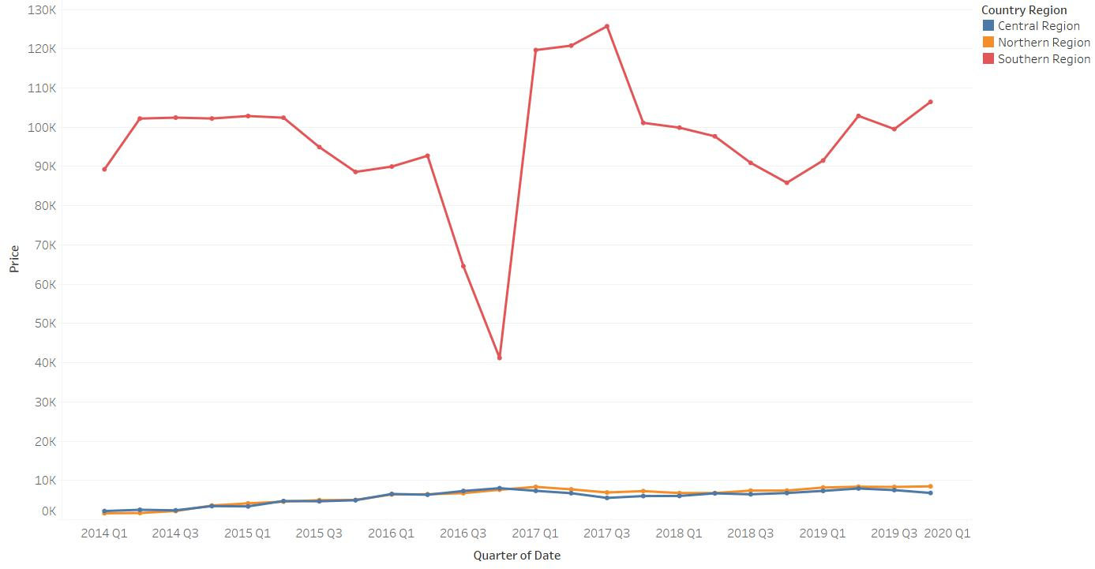

Some of the trends of the individual food crops are shown below

***Figure 3.1.5* Maize (retail) median prices trend from 2014 to 2020**

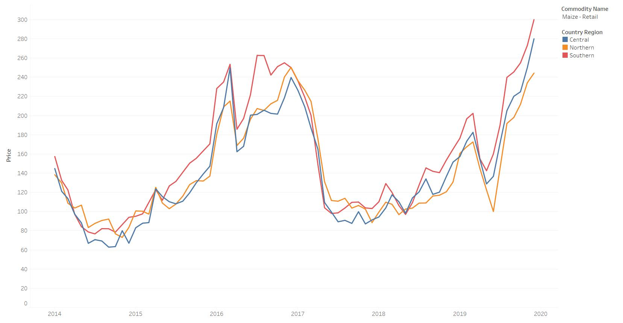

Maize has been the major food crop in terms of the policy agenda and hectarage planted. From the chart above, the median price for maize in markets of the southern region significantly rose from October in 2014, up to the first quarter of 2016, only dropping briefly once from April to May 2015. Therefore, we can conclusively claim the flood impacted the price of Maize.

***Figure 3.1.6* Cassava (retail) median prices trend**

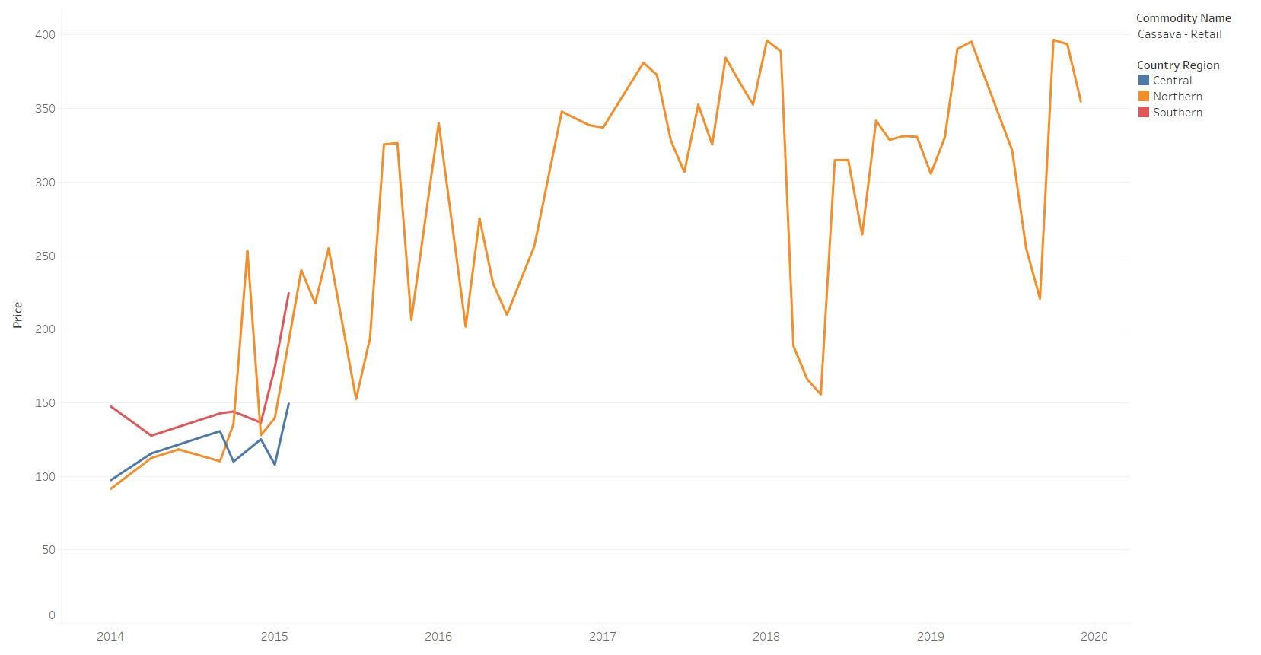

The trend chart for Cassava reported no values for the southern and central regions from February 2015. This could be as a result of incompleteness of data.

## 3.2 Agriculture

## Malawi agriculture is composed of two main subsectors: small-scale farmers and estates. Smallholder farmers comprise an estimated 2 million farm families and cultivate about 4.5 million hectares of land. Smallholder production is highly subsistent. It is characterized by low levels of input and low output levels. Approximately 25 percent of smallholder farmers cultivate less than 0.5 ha on average; 55 percent cultivate less than 1.0 ha; 31 percent cultivate between 1.0 and 2.0 ha; and 14 percent cultivate more than 2.0 ha. But despite being resource-poor, smallholder farmers produce about 80 percent of Malawi’s food and 20 percent of its agricultural exports.

The most immediate impact of erratic rainfall on rural livelihoods is on crop production. Droughts and floods undermine farm yields and the national harvest, reducing household and national food availability, and agricultural income derived from crop sales. Poor harvests threaten food security and livelihoods from household to national level, to varying degrees according to the extent that the family or nation depends on agriculture for its food and income. Households and economies that are more diversified are less vulnerable to these direct impacts of droughts and floods, provided that their alternative income sources are neither correlated

with rainfall nor directly or indirectly dependent on agriculture (i.e., vulnerability falls to the extent that complementary sources of income and food are non-covariate). The figure below shows the

***Figure 3.2.1* Malawi monthly average rainfall from 2005 to 2016**

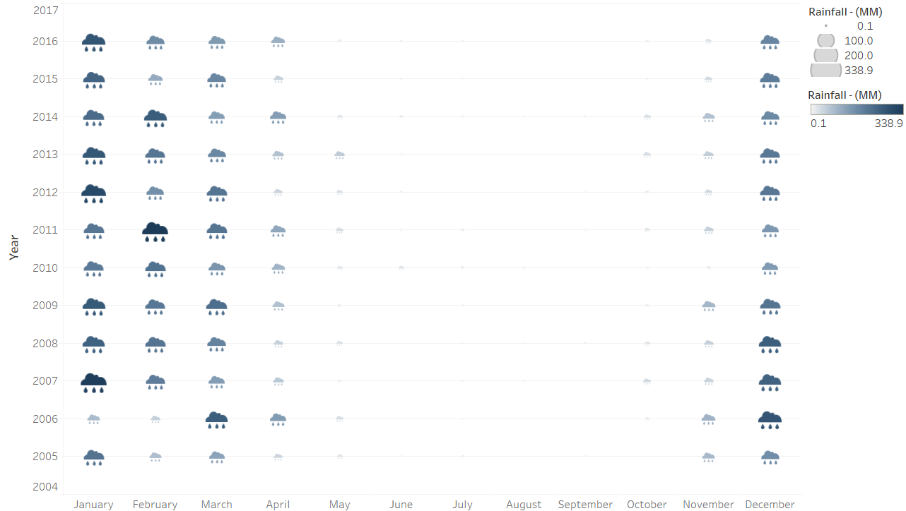

Figure 2: Categories of food and regions in Malawi

Figure 3: Overall sum of food prices (Monthly)



Figure 4: Overall sum of food prices (Quarterly)



Figure 5: Cassava retail median prices trend by region



Figure 6: Maize retail median prices trends by region



Figure 7: Rice retail median price trend by region

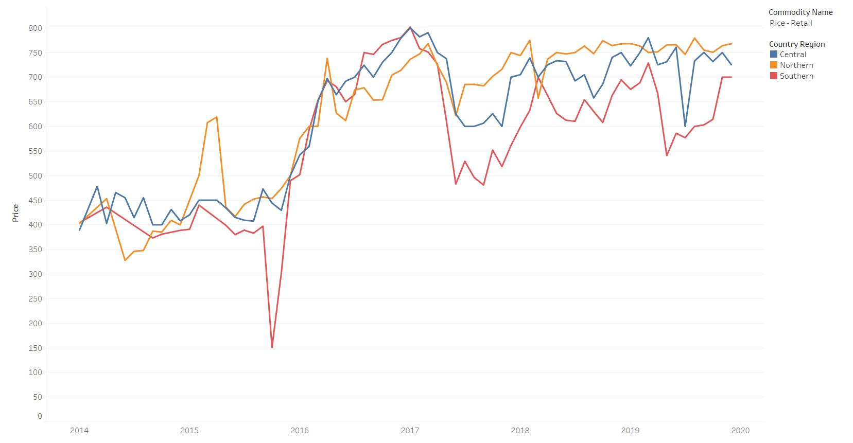

Figure 8: Sorghum retail median price trend by region

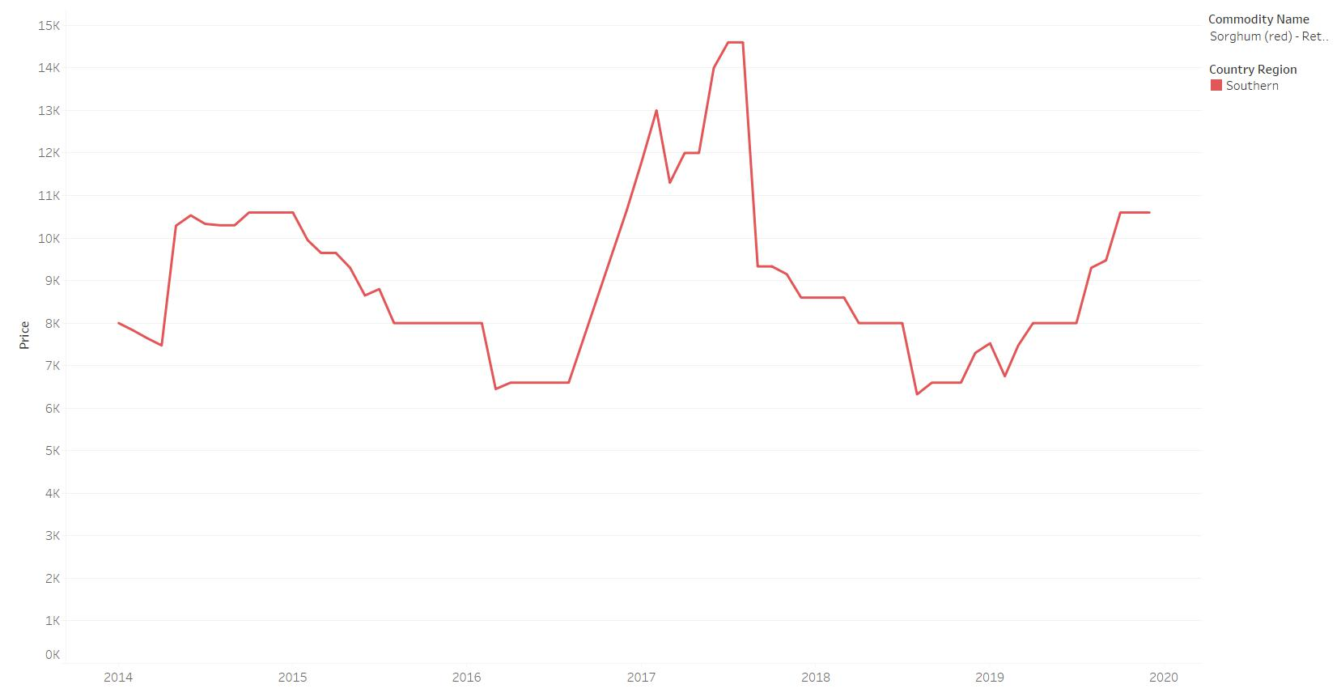

## 3.3 Food security Indicators

a. The average dietary energy supply was increasing before 2015 and did not increase nor decrease after.

b. The average value for food production was on low before 2015, it went down further afterwards

c. GPD per Capital went down in 2015

d.

Figure 9: Average dietary energy supply Adequacy

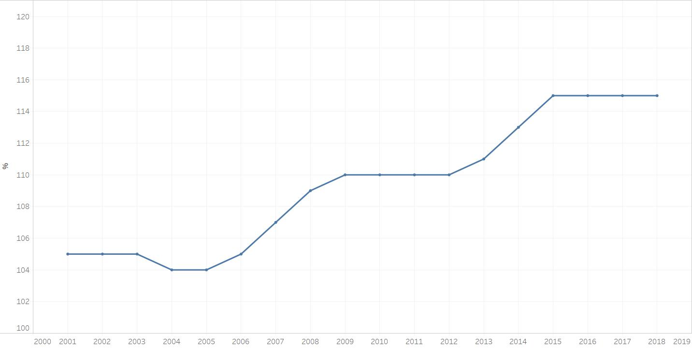

Figure 10: Average value of food production

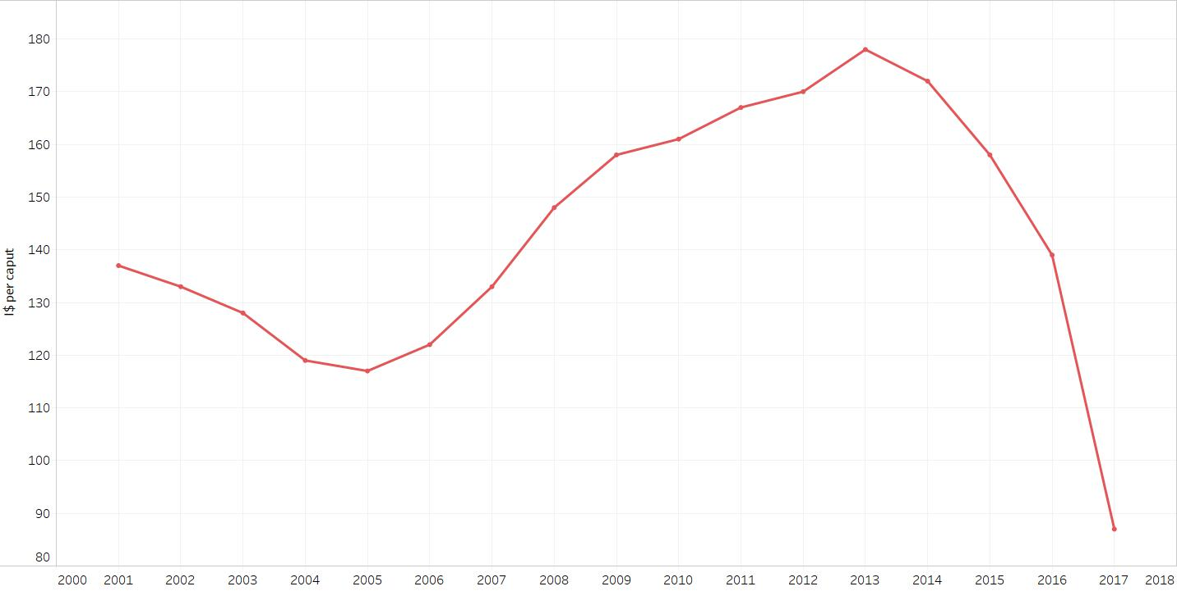

Figure 11: GPD per Capital

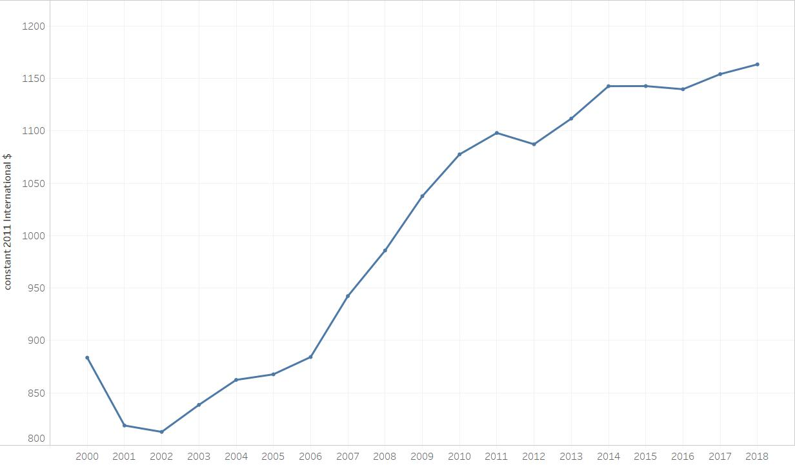

Figure 12: Nutritional status of Children by Years

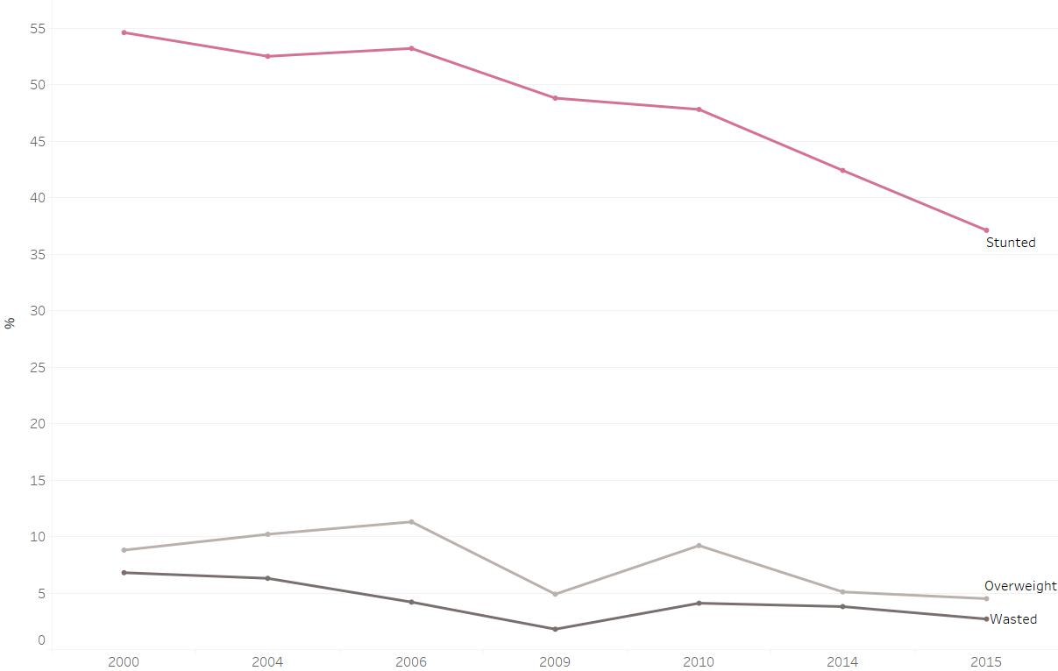

Figure 13: Percentage of Arable Land for Irrigation

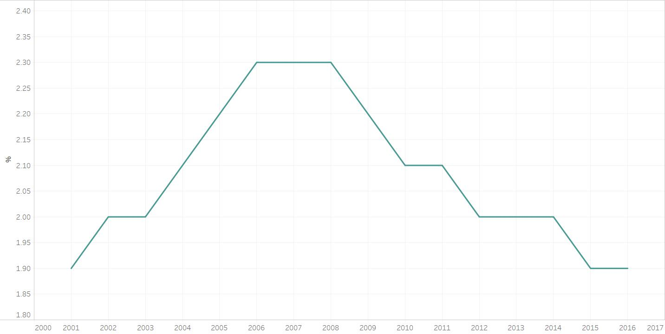

Figure 14: population using sanitation services

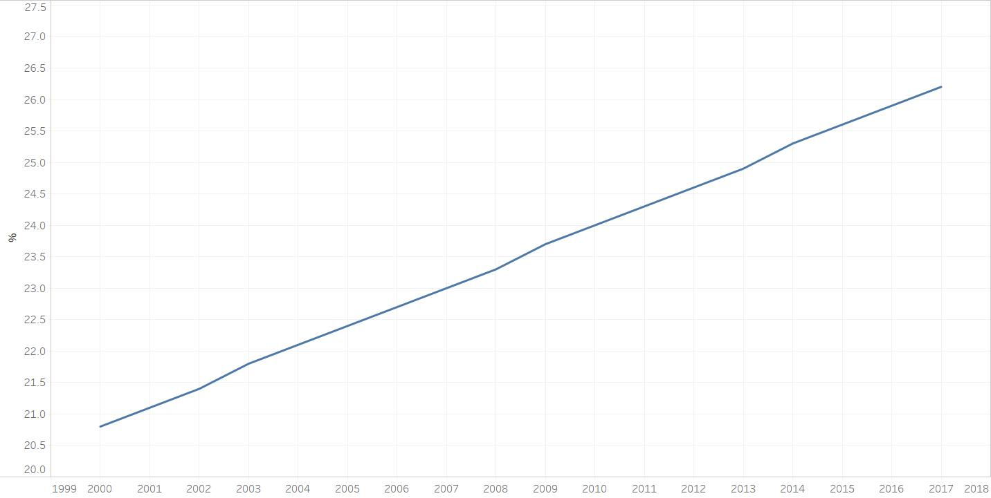

Figure 15: prevalence of undernourishment

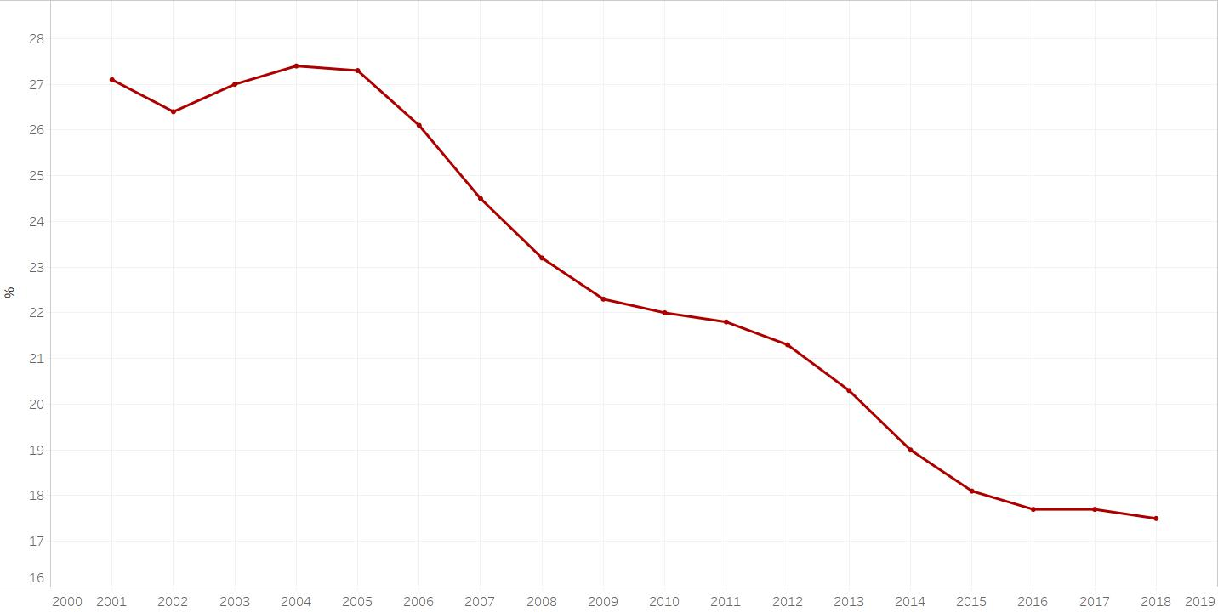

## 2.4 Healthsites

The Healthsites data constituents the amenities available in Malawi.

## 2.5 Precipitation data

Our precipitation data came from climateknowlegdeportal.worldbank.org/download-data. We were able to visualize how heavy rainfall was for each month. It was measured in mm

Figure 15: Perecentage of available amenities in Malawi

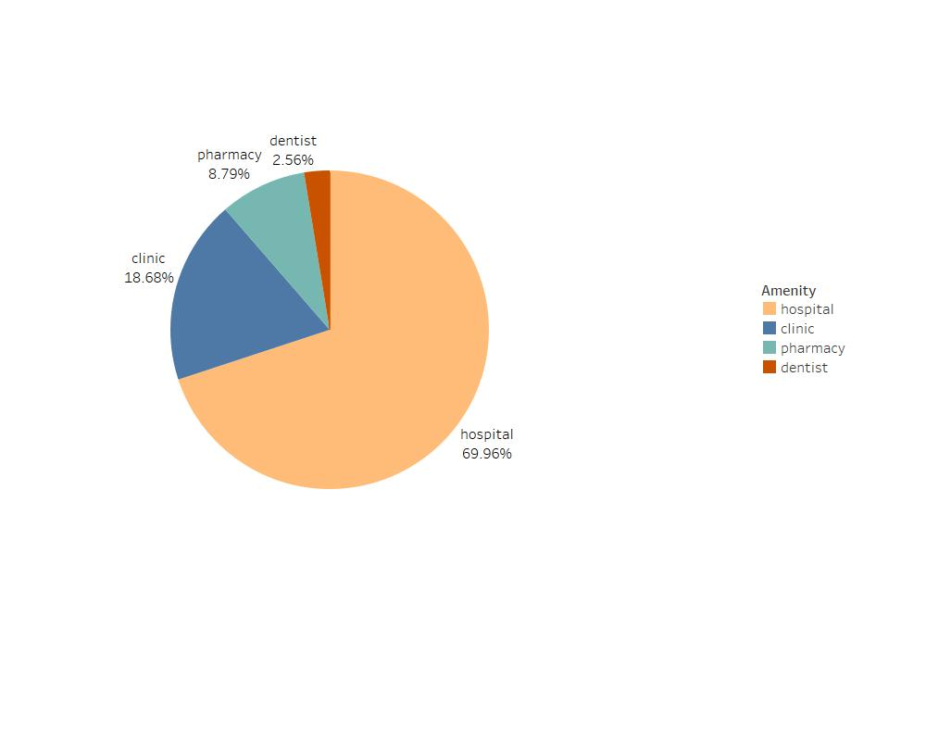

Figure 15: Average monthly rainfall in Southern Malawi



Healthsites. Average dietary supply was increasing over ears frm 2005 and wen flalined from 2015

b. percent of arable land good equip for irrigation a steep drop of percent from 2014- 2015 and remained unchanged

c. lower imports means gdp is increasing,flalined from 2014 p 15 and dropped briefl in 2016 hen increased

1. Percentage of arable land for crop goes down from 2007

Antenatal Care provider statistics from 2010 to 2017

# LIMITATIONS

We found variability in results between the regions in Malawi. However, the analysis is limited by data availability, as the DHS samples are too small to look at regions within-country variability. A related limitation is the spatial scale of the analysis. DHS samples are rarely representative within sub-national regions, which limits our ability to examine the flood exents within specific regions of a country. This modest number of clusters means that some areas that are flood or drought prone may not be covered by the DHS data, limiting our ability to test robustness.

In this study, we have not investigated factors that influence the vulnerability of households to flooding such as the building quality, or other determinants of flood impacts such as flood duration, (Dang et al., 2010; Parker et al., 1987), and its impact on indirect losses such as loss in output and revenue and economic disruption (Lekuthai and 382 Vongvisessomjai, 2001) and flood-related health issues; and flood level rise rate which is 383 especially important in terms of mortality (Jonkman et al., 2009).

# CONCLUSION

The general conclusion of this report is that poor people are disproportionally exposed to rural floods. A particular concern is the fact that some of the regions where poor people are overexposed will also experience more frequent flooding in the future due to climate change. Government should enforce land-use regulation, risk-sensitive land-use policies that protect poor people, such as flood zoning and land entitlement support the access of poor people to opportunities and not stifle them. The results suggest that integrating local knowledge in developing localised and relevant climate change adaptation strategies is essential in Malawi. This can be achieved by creating a forum for interaction between scientists and indigenous knowledge holders.

# References

Malawi 2019 Floods Post Disaster Needs Assessment Report, 2019

Er-Xuan Sung, Meng-Han Tsai, Shih-Chung Jessy Kang , An Interactive Data Visualization System for Flood Warnings in Taiwan, 2013

Standard Operating Procedure for Early Warning System in Malawi

Government of Malawi. 2010. Second National Communication of Malawi. Ministry of Natural Resources and Environmental Affairs, Lilongwe, Malawi.

fao.org/3/y4632e/y4632e0n.htm#fnB85

Our precipitation data came from climateknowlegdeportal.worldbank.org/download-data